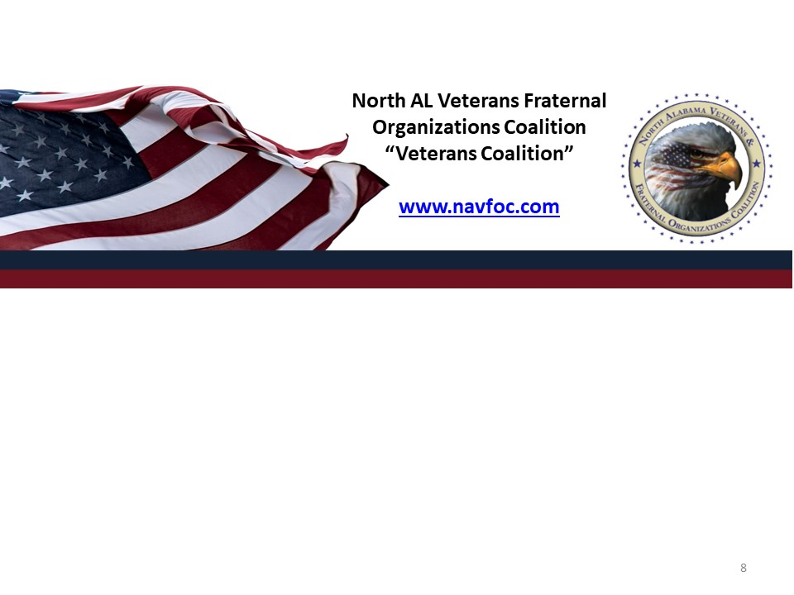
PO BOX 511, HUNTSVILLE, AL 35804

Deadline to submit a nomination: Sept 15, 2024
Late entries will not be accepted or considered
PLEASE SUBMIT YOUR NOMINATION VIA EMAIL TO: seccoalition@gmail.com
VETERAN OF THE YEAR NOMINATION
Veteran Nominee’s Name: ____________________________________________
Phone: __________________________ Email: ____________________________
Nominating Organization Point of Contact:
Name: ________________________________
Phone: __________________________ Email: ____________________________
PLEASE REMEMBER THE NOMINATING ORGANIZATION IS RESPONSIBLE FOR
VERIFYING THE LEGITIMACY AND VOLUNTEER WORK THIS VETERAN HAS
CONTRIBUTED TO THE NORTH ALABAMA COMMUNITIES AND VETERANS
ORGANIZATION.
List of Volunteer work your nominee has performed past year from September 2023 to August 2024:

Narratives of his/her volunteer work past year: (No more than 500 words
please)

Tell us why your nominee should be selected for the 2024 Veteran of the Year:
(No more than 250 words)

