PO Box 511, Huntsville, AL 35804

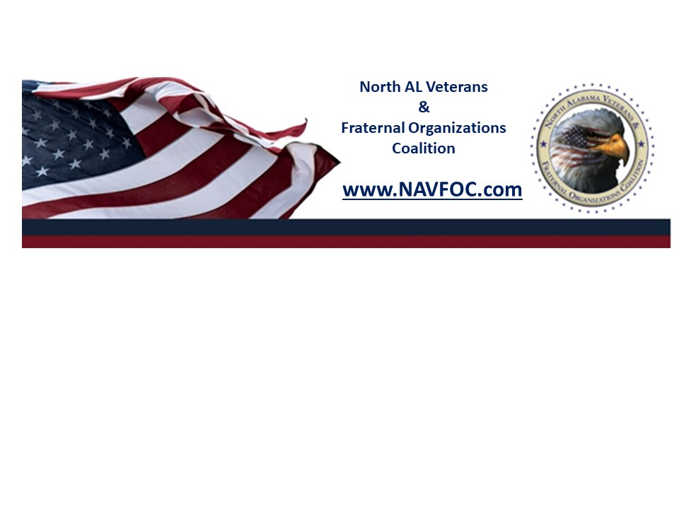
North AL Veterans & Fraternal Organizations Coalition
Board Nomination Form

The candidate must be an active member of the NAVFOC organization who paid the annual dues.

Please check: ___ Nominating Organization ___ Self Nomination

Who is nominating this candidate?
Your Name: ___________________________________
Your position with the nominating organization: ____________________________
Email: ____________________________________ Cell: _________________________

Position Nominating for: ________________________________________________

Is your candidate aware of this nomination: ___YES ___NO
(Please remember to ask your nominee, if they are selected, will accept the position nominated for)

Candidate’s Name: ______________________________________________________

Email: ____________________________________ Cell: _________________________

Candidate’s position with nominating organization: ________________________
How long has this candidate held a position with the nominating organization?
________________________

Please provide the candidate’s volunteer work history and achievements in the last three years. (no more than 500 words:

Candidate’s vision for the NAVFOC (No more than 300 words):

Is your candidate willing to accept another position if not selected for a position nominated for? ____YES ____NO

Contact Information:

Please send the completed form to eugene.roberts@outlook.com
Deadline to nominate: October 31, 2024

