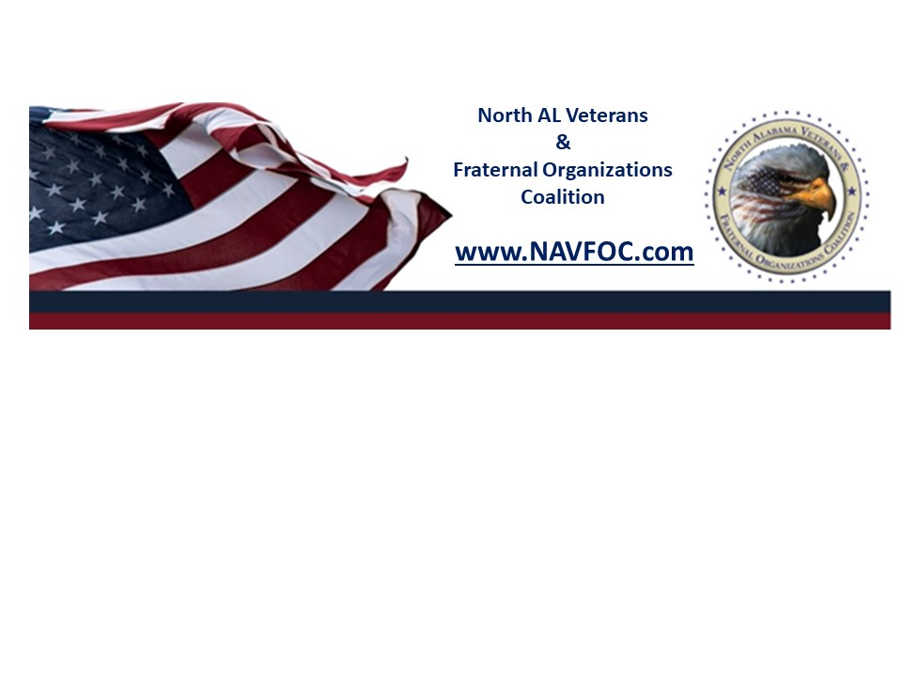

North Alabama Veterans Fraternal Organizations of Coalition
P.O. Box 511
Huntsville, Alabama 35804

2023 Financial Support Request Form
A funding request form must be submitted to the President of the North Alabama
Veterans and Fraternal Organizations known as the Veterans Coalition.

The funding request is open only for the active member organizations who paid
annual dues to the Veterans Coalition at least three months prior to a request.

Submitting the funding request is NOT a guarantee. Funding requests must clearly
define the project/activity in relation to the VETERANS COALITION missions
and objectives. Funds WILL NOT be granted for individual requests under any
circumstances. Please submit your request to: presidentcoalition@gmail.com

Financial support will be granted based on the following criteria;

1. Funds availability.
2. Mission-critical of the organization requesting financial support.
3. Request must be submitted in a timely manner at least six weeks in advance for
the board of directors to review and evaluate circumstances and time for the voting process to be completed.
4. Request for funding after the event WILL NOT be granted in any circumstances.

The following information for consideration by the Board of Directors:

Name of Requesting Organization: ______________________________________

Amount of Funds Requested: $

Is this request budgeted and approved by the Veterans Coalition Board of Directors and the General member organizations? Yes/No (Please circle one)

Describe the event, purpose, date, and location: (no more than 50 words, please:

Date: Time: Location:

How will Soldiers, Veterans, and their Families benefit (no more than 150 words,
please):

Please provide the following:

Will the Veterans Coalition Board of Director(s) be invited to your event if supported by Veterans Coalition? Yes/No (please circle one)

Who can provide additional information about this event if needed?

Name: Title:
Cell #: Email:

Signature Title of Requester

Date Request Submitted

