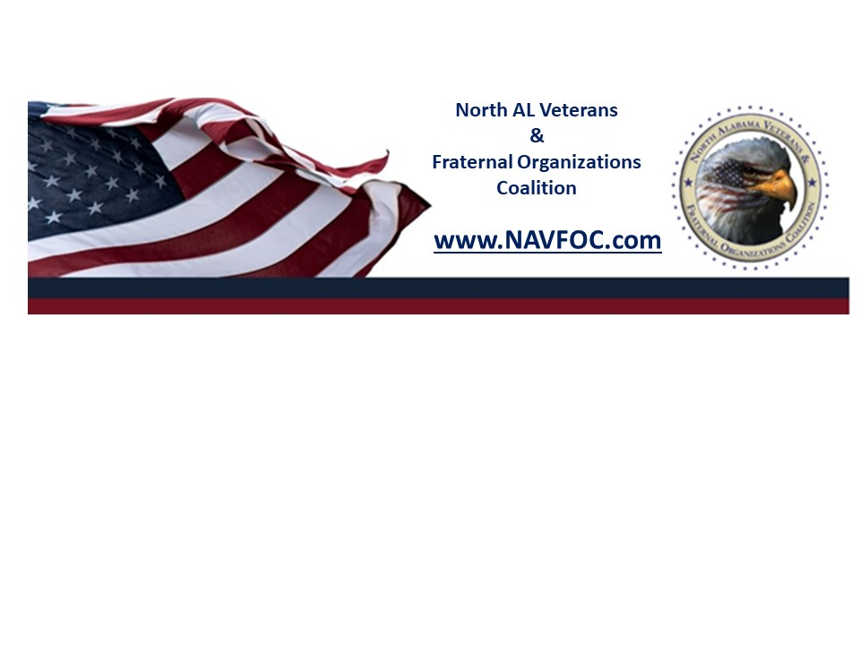
Dear Veterans Coalition New Applicants:
In December 2001, the North Alabama Veterans & Fraternal Organizations Coalition (NAVFOC/Veterans Coalition) became a Charitable 501 (c)(3) Nonprofit organization.
Since that time, the organization has been known by both NAVFOC and the Veterans Coalition. In order to avoid confusion, going forward the organization will identify as the Veterans Coalition.

If your organization is a Tax Exempt, Veterans, or Fraternal organization and wishes to
become a member of the Veterans Coalition, please fill in your organization’s information below and send it to the President. presidentcoalition@gmail.com

The Veterans Coalition Board of Directors will review your membership application with
the VP Membership chairman. If the board of directors agrees to accept your organization into the Veterans Coalition, the VP Membership will present your organization to the general membership at the following monthly meeting for approval. And the membership chairman will contact you if we have any questions or to inform you of our process.

When your organization is up for approval, we highly encourage a representative from your organization to be present at the monthly general membership meeting to tell a little about the organization and to pay the Annual $50 dues.

Important information:
1. The $50 annual membership fee is due upon approval of your organization to join the Veterans Coalition.
2. Your organization’s POC is responsible for providing an emblem, website, or
social media address to be listed on the www.NAVFOC.com website.
3. The annual membership fee is due on October 1 each year.
4. Your membership will be revoked if your membership fee is not paid within six months of the due date. This applies to all member organizations.

Veterans Coalition does not discriminate against members based on their religion, nationality, or political affiliation. The Veterans Coalition is NOT a political organization or politically affiliated, and it does not engage in making political commentary, or lobbying. Please fill in the form and send it to: presidentcoalition@gmail.com
Please fill in the form below and send it to: presidentcoalition@gmail.com

APPLICATION FOR MEMBERSHIP OF THE
NORTH ALABAMA VETERANS & FRATERNAL ORGANIZATIONS COALITION
ORGANIZATION OFFICIAL NAME
OTHER NAMES USED FOR ORGANIZATION
TAX ID NUMBER
YEAR ESTABLISHED
WEBSITE/SOCIAL MEDIA
NUMBER OF BOARD MEMBERS
ORGANIZATION POINT OF CONTACT
POINT OF CONTACT POSITION TITLE
POINT OF CONTACT EMAIL
POINT OF CONTACT MOBILE PHONE
ORGANIZATION MISSION STATEMENT
WHY YOUR ORGANIZATION WISH TO JOIN THE VETERANS COALITION?
LIST OF ACHIEVEMENTS OR TYPE OF PROJECT ACCOMPLISHMENTS IN THE PAST TWO YEARS
OTHER INFORMATION YOU WOULD LIKE TO TELL US
Please provide two names of your officers and signatures below:
Name: Title:
Signature: Date:
Name: Title:
Signature: Date:

